St Mark and All Saints Church of England Primary School
Guildford Diocese Education Trust
Academies in partnership with the Guildford Diocese Education Trust
The Education Centre, The Cathedral, Guildford, Surrey GU2 7UP Tel: 01483 450423

Anti-Bullying Policy
(including Cyber Bullying)

Coordinator | Responsible Body
Headteacher | Good Shepherd Trust

*Updated to include Guidance from ‘Preventing and tackling bullying (July 2017)
Introduction
Bullying is the dominance of one person by another. It forms patterns of behaviour, rather than an isolated incident. Bullying in any circumstance is unacceptable. Research suggests that at least 10% of school children are involved in bullying, either as victims or bullies at any one time. All bullying damages self-esteem of both the victim and the bully, can hinder learning and may adversely affect those involved well into their adult lives. The school believes it is of paramount importance to recognise and act as early as possible whenever bullying should occur.

Equal Opportunities
We believe it is the right of all children, regardless of their gender, religion, ethnicity, physical disability, ability, linguistic, cultural or home background, to be listened to and treated fairly whenever incidents of bullying occurs.
We recognise that certain groups and individuals may be discriminated against and therefore are strongly committed to positive action to remove and counter discrimination in all aspects of the School and its work.

Aims
- To create a climate of confidence, trust and listening where disclosures of bullying are taken seriously and acted upon swiftly
- To help children recognise bullying behaviour, and know what to do should it occur
- To encourage all members of the school community to take responsibility for the care and safety of others and their property
- To help children develop the sense of right and wrong and the ability to accept responsibility as well as assert one’s rights
- Pupils, staff and parents know about cyber bullying and its consequences;
- We have the knowledge, policies and procedures to prevent and, if necessary, to deal with cyber bullying in school or within the school community;
- We monitor the effectiveness of our procedures.

Objectives
- To ensure all members of the St John’s C of E community (children, staff, parents, and governors) can recognise bullying in all forms
- To ensure that there are clear strategies for the reporting of bullying, known to everyone
- To ensure that all members of our community know the strategies for dealing with bullying behaviour and implement them consistently

Implementation

Information for Parents and Carers
Information concerning our bullying policy will be offered to parents and carers in the Schools’ prospectus and newsletters.
The policy & guidelines are sent out to all parents at the beginning of each academic year, and again when their child is involved in any capacity.

Teaching and Disclosure
- Children have opportunities to learn about bullying as part of the PSHE curriculum
- An annual anti-bullying week is organised to raise pupil awareness of what bullying is, that is it not tolerated at our school and what to do if bullying occurs.
- Issues relating to bullying are discussed during assemblies, where children will be reassured and encouraged to disclose any incident of bullying, whether or not directly involved.

Features of bullying:
• It is deliberate, hurtful behaviour
• It is often repeated over a period of time
• It is often difficult for those being bullied to defend themselves
• It is difficult for those who bully to learn new social behaviours
• The bully has, and exercises, power over the victim
Bullying can take a number of forms:
- Physical, for example hitting and kicking
- Emotional or verbal, for example name calling, exclusion, threatening and coercion.
- Damage to property
- Cyber Bullying

What is cyber bullying?
• Cyber bullying includes sending or posting harmful or upsetting text, images or other messages, using the internet, mobile phones or other communication technology.
• It can take many forms, but can go even further than face to face bullying by invading home and personal space and can target one or more people.
• It can take place across age groups and target pupils, staff and others.
• It can include threats and intimidation, harassment, defamation, exclusion or peer rejection, impersonation and unauthorised publication of private information or images.
• It can include messages intended as jokes, but which have a harmful or upsetting effect.

What is cyber bullying?
Cyber bullying may be carried out in many ways, including:
• Threatening, intimidating or upsetting text messages;
• Threatening or embarrassing pictures and video clips via mobile phone cameras;
• Silent or abusive phone calls or using the victim’s phone to harass others, to make them think the victim is responsible;
• Threatening or bullying emails, possibly sent using a pseudonym or someone else’s name;
• Menacing or upsetting responses to someone in a chat-room;
• Unpleasant messages sent during instant messaging;
• Unpleasant or defamatory information posted to blogs, personal websites and social networking sites (e.g. Facebook)
In some cases this type of bullying can be a criminal offence.

Types of cyber-bullying
- Flaming: Online fights usually through emails, instant messaging or chat rooms where angry and rude comments are exchanged.
- Denigration: Putting mean online messages through email, instant messaging, chat rooms, or websites set up to make fun of someone.
- Exclusion: Intentionally leaving someone out of a group such as instant messaging, friend sites, or other online group activities.
- Outing: Sharing secrets about someone online including private information, pictures, and videos.
- Trickery: Tricking someone into revealing personal information then sharing it with others.
- Impersonation: Pretending to be someone else when sending or posting mean or false messages online.
- Harassment: Repeatedly sending malicious messages to someone online.
- Cyber-stalking: Continuously harassing and denigration including threats of physical harm.

Actions NOT considered to be bullying
- Not liking someone
- Being excluded
- Accidentally bumping into someone
- Making other kids play things a certain way
- A single act of telling a joke about someone
- Arguments
- Expression of unpleasant thoughts or feelings regarding others
- Isolated acts of harassment, aggressive behaviour, intimidation, or meanness

Prevention of Cyber Bullying
Understanding and information

The Head will act, as an e-Safety Officer, to oversee the practices and procedures
outlined in this policy and monitor their effectiveness.
• The e-Safety Officer will ensure that the school maintains details of agencies and resources that may assist in preventing and addressing bullying.
• Staff will be trained to identify signs of cyber bullying and will be helped to keep informed about the technologies that children commonly use.
• A Code of Advice (see Appendix 1) will be developed, periodically reviewed and communicated to help pupils protect themselves from being caught up in cyber bullying and to advise them on reporting any incidents.
• Pupils will be informed about cyber bullying through curricular and pastoral activities.
• Pupils and staff are expected to comply with the school’s Acceptable Computer Use Policy.
• Parents will be provided with information and advice on cyber bullying.
Reasons for bullying
Some reasons why children might bully someone include:
- They think it's fun, or that it makes them popular or cool
- They feel more powerful or important, or they want to get their own way all the time
- They feel insecure or lack confidence or are trying to fit in with a group
- They are fearful of other children's differences
- They are jealous of another child
- They are unhappy
- They are copying what they have seen others do before, or what has been done to them.

Practices and Procedures

• The responsibilities of the school and of pupils as set out in the Anti-Bullying Policy apply
also to this policy.
• Positive use of ICT will be promoted and the Acceptable Computer Use Policy will be kept under review as technologies develop.
• CPD and INSET may be used to help staff develop their own practices and support pupils in safe and responsible use of ICT.
• The school will encourage safe use of ICT, emphasising, for example, the importance of password security and the need to log out of accounts.
• The school will promote the message that asking for help is the right thing to do and all members of the school community will be informed how cyber bullying can be reported.
- challenge sexual content within verbal abuse especially challenging the word ‘gay’ and other homophobic language.
• Confidential records will be kept of all cyber bullying incidents.

Bullying which occurs outside school premises
Bullying which occurs outside school premises School staff members have the power to discipline pupils for misbehaving outside the school premises. Sections 90 and 91 of the Education and Inspections Act 2006 say that a school’s disciplinary powers can be used to address pupils’ conduct when they are not on school premises and are not under the lawful control or charge of a member of school staff, but only if it would be reasonable for the school to regulate pupils’ behaviour in those circumstances. This may include bullying incidents occurring anywhere off the school premises, such as on school or public transport, outside the local shops, or in a town or village centre. Where bullying outside school is reported to school staff, it should be investigated and acted on. The headteacher should also consider whether it is appropriate to notify the police or anti-social behaviour coordinator in their local authority of the action taken against a pupil. If the misbehaviour could be criminal or poses a serious threat to a member of the public, the police should always be informed. While school staff members have the power to discipline pupils for bullying that occurs outside school, they can only impose the disciplinary sanction and implement that sanction on the school premises or when the pupil is under the lawful control of school staff, for instance on a school trip.

DEALING WITH INCIDENTS OF BULLYING BEHAVIOUR
When dealing with incidents of bullying, the School will respond in a way that will support the victim and assist the bully in improving their future behaviour. Further intervention / action will be taken if behaviour is not improved.
All staff should be vigilant in recognising bullying behaviour by:
- Noting and acting upon disclosure / comment by a child
- Noting and acting upon parent/carer concern.
- Monitoring and recording incidents
- Identifying patterns
- Listening to comments made when teaching about bullying.
When disclosures of bullying occurs the following steps will be taken by the member of staff dealing with the disclosure:
- Talk with the “victim” about their feelings, gather specific details of the alleged bullying behaviour and clarify the names of the people who are involved in the issue.
- Gather details by talking with the people involved. This will include bystanders/colluders who joined in but did not initiate any bullying. The adult should make it clear that the bullying behaviour is unacceptable, that a change in behaviour has to occur form this point on and that further action will be taken if any further issues occur.
- The incident should be recorded on an incident/concern sheet. Details should include place and time of bullying, events immediately preceding the incident / actions following the incident and any other relevant background information. The entry should be signed and dated.
- The group will be asked to take responsibility and decide ways of resolving the issue.
- Each member of the group will be asked to suggest a way in which the victim could be helped and detail action that they will take to improve their behaviour from this point on. Positive responses will be used as encouragement. Agreed ‘new’ behaviours must be recorded on the incident sheet and Pupil Asset
- Monitoring arrangements (i.e. meeting with the children / group at the end of each day) will be explained to all those involved. The issue must be monitored for at least 2 weeks following the disclosure, and class teachers kept informed.
- At the end of the day parents / carers of both the “victim” and the “perpetrator/s” will be informed by telephone if possible, if not then by sending the incident sheet home. It should be made clear that supportive action from parents is required. The parent’s response to the incident should be noted on the school’s copy of the incident sheet. Copy of sheet to be given / emailed to HT, DH and copy in pupil file.
- At the end of the period of monitoring, the record sheet is sent home to the parents of all children involved.

If further incidents occur, matter is referred to ant member of the Senior Leadership Team:
- Details of incident / names of involved / dates etc recorded on an incident sheet
- Gather further evidence of allegation by interviewing named individuals.
- Parents / Carers of both victim and perpetrator must be informed and a separate meeting for each arranged to take place within 24 hours of the school being notified of the continuing issue & agree joint action to be taken to resolve the bullying.
- Parent’s / Carer’s of perpetrator informed of the sanction that is being imposed:
Break / Lunchtime exclusion for between 5 – 10 days if bullying is occurring at lunchtime. Collection arrangements for the lunchtime period should be agreed.
If further incidents occur, the matter is referred to either the HT or DH:
- Repeat actions 1-3
- Parent’s / Carer’s of perpetrator informed of the sanction that is being given: Fixed term exclusion for up to 5 days.
- Before returning to school, HT to meet with parents / Carers to explain conditions under which the child maybe readmitted to the school.

Staff Development
Staff training takes place at least annually to help staff recognise and deal with any incidence of bullying.
The anti-bullying policy is included in the induction of new staff.

Staff Development
Staff training takes place at least annually to help staff recognise and deal with any incidence of bullying.
The anti-bullying policy is included in the induction of new staff.

Monitoring and Review
Staff are aware of the need to reward all children. It is especially important that positive recognition is given to all pupils, particularly those who adapt their behaviour to supporting a previous victim of bullying.
All incident/concern sheets are kept on file and reviewed by the SLT termly. Further action on a year group / whole school basis will be implemented should monitoring show there is a need

Example – monitoring record

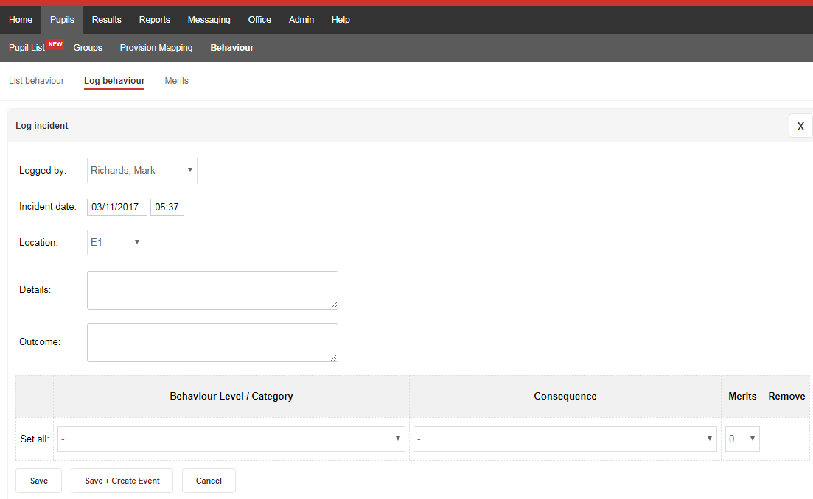

St Mark and All Saints CE Primary School
Mr M Richards Mrs C Mallett
Headteacher Deputy Headteacher
CONTACT / CONCERN SHEET
Date: | Time: |  | Person completing report
Name /s of child / ren involved: |  |  | Class/es – please highlight / circle
Contact:  Parent / Carer |  | Name / contact details:
Details of contact

Action taken / Agreed: |  |  |  | By whom | By when
CC: Office / HT – file

Please sign below to inform the school you have read the above

_________________________________(Parent /carer) _______ (date)

The Good Shepherd Trust : GB doc – 8 Charity Number: 248245
Preventing and tackling bullying Government advice
https://www.gov.uk/government/uploads/system/uploads/attachment_data/file/623895/Preventing_and_tackling_bullying_advice.pdf

Appendix 1
Cyber Safety Code
Three Steps to Safety
1. Respect other people - online and off. Don’t spread rumours about people or share their secrets, including phone numbers or passwords.
2. If someone insults you online or by phone, stay calm. Ignore them, but tell
someone you trust.
3. “Do as you would be done by!” Think how you would feel if you were bullied. You are responsible for your behaviour - so don’t distress other people or encourage others to do so.
If you are being bullied
It is never your fault. It can be stopped and it can usually be traced.
• Don’t ignore the bullying. Don’t reply, but do tell someone you can trust, such as a teacher or parent, or call an advice line.
• Try to keep calm. If you seem frightened or angry it will only make the person bullying you more likely to continue.
Text / video messaging
• You can turn off incoming messages for a couple of days.
• If bullying persists you can change your number (ask your mobile phone provider).
• Do not reply to abusive or worrying messages. You can report them to you mobile phone provider.
Email
• Never reply to unpleasant or unwanted messages.
• Don’t accept emails or open files from people you don’t know.
• Don’t delete bullying emails – print them or save them as evidence in a separate folder.
Social networking sites, chatrooms and instant messaging
• Change privacy settings so you can choose who to be friends with and who can see your profile. Don’t add anyone you don’t know to your friend list.
• Don’t use your real name in chatrooms.
• Never give out your photo or personal details, like your address, phone number or which school you go to.
Don’t post any pictures or videos you wouldn’t be happy for your parents or teachers to see. Once they are online they can be copied and posted in other places where you can’t get rid of them.
• Keep your passwords private and don’t tell anyone, not even your best friend.
• To report suspicious behaviour online and to learn more about keeping yourself safe online visit www.thinkyouknow.co.uk

Always report bullying incidents. Not doing that allows the bully to continue. That’s not good for the victims, for those who witness the incidents or for the bully, who may need help to change their antisocial behaviour

